Creating an XLL Project in Visual Studio 6
To create your XLL project, choose File/New from the Visual Studio menu and select the Projects tab. Choose the Win32 Dynamic-Link Library project type, give your project the name Sample, and select a location for your project. Click OK and accept the default option of an empty DLL project in the next dialog by clicking Finish.

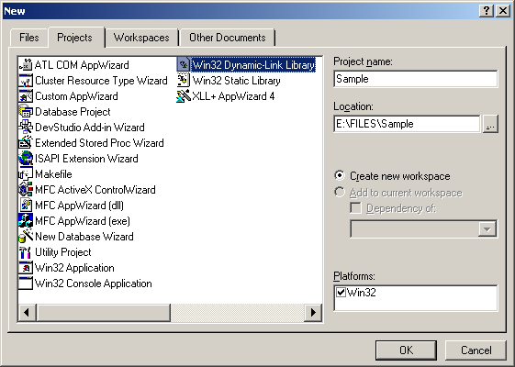
Figure 1 – Creating the initial XLL Project

Now add a code file to your project by selecting File/New from the Visual Studio menu and choosing the Files tab. Select the C++ Source File type from the listbox, enter the name Sample.c in the File name textbox, and click OK.

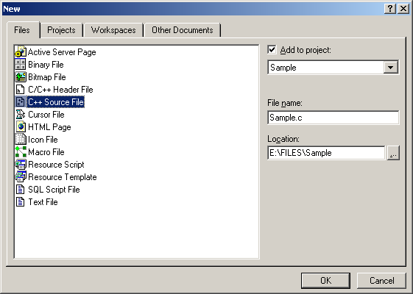
Figure 2 – Adding the Source Code File to Your Project

We will also need a module definition (.DEF) file for our project in order to prevent Visual C++ from exporting mangled function names from our XLL. Again, select File/New from the Visual Studio menu and choose the Files tab. Select the Text File entry from the list, enter the name Sample.def in the File name textbox, and click OK.
Now all we need to do is make a few additional project settings and we’ll be ready to start writing code. Choose Project/Settings from the Visual Studio menu and choose Win32 Debug in the Settings For dropdown. Next, select the Debug tab and use the arrow button next to the Executable for debug session entry to locate the Excel.exe program file on your system. This will allow you to interactively debug your XLL while using it in Excel.

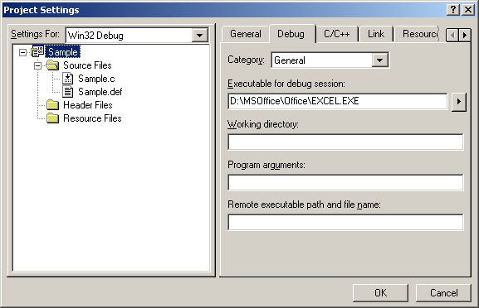
Figure 3 – Enabling Interactive Debugging with Excel

When debugging an XLL, once the VC++ debugger has started Excel you'll need to File/Open the XLL file from the Excel user interface in order to test it. For ease of use during multiple debugging sessions, add the XLL to the list of add-ins that will be loaded automatically by Excel on startup using the Browse button on the Add-ins dialog displayed by the Tools/Add-ins menu.
Next, select the C/C++ tab. Change the Debug info setting to Program Database rather than its default of Program Database for Edit and Continue. The latter adds tokens to the compiled project that cause Excel not to recognize it as a valid XLL.

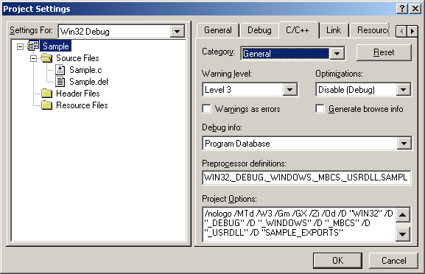
Figure 4 – Setting Debug info to Program Database

Now select the Link tab. Change the Output filename from Sample1.dll to Sample1.xll. Select Win32 Release in the Settings For dropdown and make the same file name change.

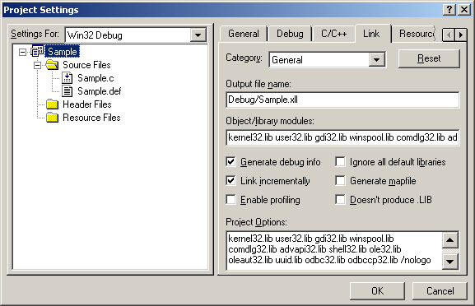
Figure 5 – Setting the Output file name

Lastly, select All Configurations from the Settings For dropdown and add the filename xlcall32.lib to the end of the Object/library modules list.

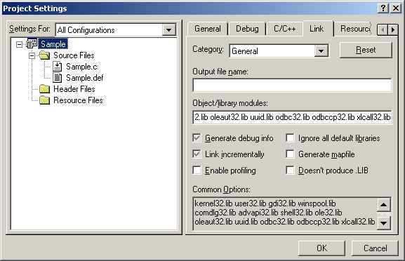
Figure 6 – Adding xlcall32.lib to the library modules list

Click OK to apply the modified project settings. You’re now ready to begin writing code.

